**Native Mobile Programming (CSM3505)**

**Lab Report 4**

Lecturer: Dr. Rabiei Mamat

Programme: Computer Science (Software Engineering)-K3

Name: Nicholas Chan Chee Kin

Matrix Number: S63128

Date: 24 November 2022

**Quiz Score**

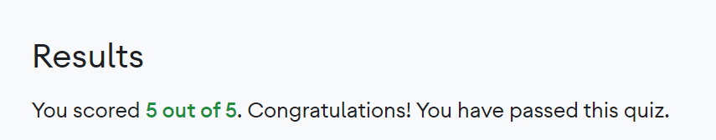**Quiz Pathway 1**

**Quiz Pathway 2**

**Quiz Pathway 3**

**Badges**

**GitHub links**

1. [**https://github.com/cnicholas01/CSM3505-Lab-4---Classes-and-Inheritance-in-Kotlin**](https://github.com/cnicholas01/CSM3505-Lab-4---Classes-and-Inheritance-in-Kotlin)
2. [**https://github.com/cnicholas01/CSM3505-Lab-4--Calculate-Tip**](https://github.com/cnicholas01/CSM3505-Lab-4--Calculate-Tip)
3. [**https://github.com/cnicholas01/CSM3505-Lab-4--Change-App-Icon**](https://github.com/cnicholas01/CSM3505-Lab-4--Change-App-Icon)
4. [**https://github.com/cnicholas01/CSM3505-Kab-4--Polished-User-Interface**](https://github.com/cnicholas01/CSM3505-Kab-4--Polished-User-Interface)
5. [**https://github.com/cnicholas01/CSM3505-Lab-4--Instrumentation-Test**](https://github.com/cnicholas01/CSM3505-Lab-4--Instrumentation-Test)
6. [**https://github.com/cnicholas01/CSM3505-Lab-4--Use-List/tree/main**](https://github.com/cnicholas01/CSM3505-Lab-4--Use-List/tree/main)
7. [**https://github.com/cnicholas01/CSM3505-Lab-4--Recycler-View**](https://github.com/cnicholas01/CSM3505-Lab-4--Recycler-View)
8. [**https://github.com/cnicholas01/CSM3505-Lab-4--List-of-Images-Using-Card**](https://github.com/cnicholas01/CSM3505-Lab-4--List-of-Images-Using-Card)
9. [**https://github.com/cnicholas01/CSM3505--Lab-4--Test-List-and-Adapter**](https://github.com/cnicholas01/CSM3505--Lab-4--Test-List-and-Adapter)
10. [**https://github.com/cnicholas01/CSM3505-Lab-4--Dogglers-App**](https://github.com/cnicholas01/CSM3505-Lab-4--Dogglers-App)